**Refugee Techpreneurs**

**BSc. in Software Engineering**

**Your Name: Sabir Walid Abdurahman**

**Supervisor:** [**Pelin Mutanguha**](mailto:pmutanguha@alueducation.com)

**Month/Year: May 2025**

**Declaration**

I, Sabir Walid Abdurahman, hereby declare that this project proposal titled “Refugee Techpreneurs” is my original work and has not been submitted to any other institution or university for any academic award. All sources of information used have been duly acknowledged.

Signed: _Sabir Walid Abdurahman

Date: _5/27/2025

**Abstract**

In South Sudan, a region marred by years of civil war and economic instability, more than 500 students graduate from secondary school each year from refugee camps. However, less than 3% of these students gain access to higher education, resulting in widespread youth unemployment, lack of digital literacy, and systemic dependence on humanitarian aid (UNHCR, 2022). With limited access to digital infrastructure and entrepreneurial opportunities, refugee youth find themselves locked out of the global economy and unable to contribute meaningfully to their communities.

Traditional interventions have primarily focused on providing basic needs and primary education, often excluding advanced technical training and entrepreneurship programs. Online learning platforms such as Coursera and Khan Academy are not optimized for the socio-economic and infrastructural conditions of refugee communities (Coursera, n.d.; EdX, n.d.). This has left a significant gap in tailored educational solutions for refugee youth.

This project, **Refugee Techpreneurs**, introduces a full-stack web application that serves as a digital innovation hub for refugee youth aged 17–30. The platform offers AI-powered career assessments, customized learning paths in digital and green technologies, startup incubation support, access to mentors, and an opportunities portal for scholarships and funding. By integrating technology and entrepreneurship, the platform aims to empower refugee youth to become self-reliant changemakers in their communities. The proposal details the background, literature review, methodology, system design, and anticipated socio-economic impacts.

**Table of Contents**

1. Declaration
2. Abstract
3. Table of Contents
4. List of Tables
5. List of Figures
6. List of Acronyms/Abbreviations
7. Chapter One: Introduction
8. Chapter Two: Literature Review
9. Chapter Three: System Analysis and Design
10. References

**List of Tables**

* Table 1: Research Timeline (Gantt Chart)

**List of Figures**

* Figure 1: System Architecture Diagram
* Figure 2: ERD Diagram
* Figure 3: Use Case Diagram
* Figure 4: Class Diagram

**List of Acronyms/Abbreviations**

* AI – Artificial Intelligence
* NGO – Non-Governmental Organization
* SDG – Sustainable Development Goal
* ERD – Entity Relationship Diagram
* CSR – Corporate Social Responsibility
* VET – Vocational Education and Training

**CHAPTER ONE: INTRODUCTION**

**1.1 Introduction and Background**

Refugees in Sub-Saharan Africa, particularly in conflict-ridden South Sudan, face immense barriers to education and economic self-sufficiency. UNHCR (2022) reports that fewer than 3% of refugee students transition to tertiary education. Of the over 500 students graduating each year from secondary schools in refugee settlements, the vast majority are unable to access higher education due to logistical, financial, and infrastructural challenges. This educational gap contributes to high unemployment, poor mental health, and reliance on international aid.

Traditional solutions offered by NGOs include food distribution, basic education, and vocational training. While helpful, they rarely provide the comprehensive, future-oriented skill sets that today’s digital and entrepreneurial economies demand (Betts et al., 2017). On the other hand, global software solutions like Khan Academy and Coursera lack customization for low-bandwidth environments and are not built to address the psychological and cultural contexts of refugees (Coursera, n.d.; EdX, n.d.). These approaches are insufficient to prepare youth for real-world job markets or entrepreneurial endeavors.

The rise of low-cost smartphones and mobile internet penetration in Africa provides an opportunity to close the gap. A software-centric intervention that offers low-bandwidth access, personalized learning, mentorship, and startup support can enable refugee youth to transition from aid recipients to self-reliant innovators (Aikins & White, 2019).

**1.2 Problem Statement**

Despite the rise of global ed-tech platforms and NGO-led vocational programs, refugee youth in South Sudan remain underserved in terms of personalized, scalable, and relevant technical and entrepreneurial education (UNHCR & ILO, 2020). Existing platforms such as **RefugeeCode.org** and **NaTakallam** offer valuable services but fall short on several fronts. RefugeeCode.org, for example, focuses solely on software development with no support for green technologies or entrepreneurship, while NaTakallam primarily offers translation services, which do not scale well for broader youth populations (RefugeeCode.org, n.d.; NaTakallam, n.d.).

Both platforms also rely heavily on high-bandwidth internet connections and are not designed to adapt to varying levels of learner preparedness. As a result, refugee communities remain educationally disenfranchised and economically stagnant. This project aims to fill this gap by developing a holistic digital platform that addresses both the educational and entrepreneurial aspirations of refugee youth through AI, modular learning, and integrated mentorship.

**1.3 Project’s Main Objective**

To develop a responsive, web application that equips refugee youth with relevant technical and entrepreneurial skills, enabling them to launch startups, pursue further education, or find remote employment.

**1.3.1 Specific Objectives**

1. To conduct a detailed needs assessment among refugee youth to understand their educational backgrounds, interests, and digital competencies.
2. To design and implement a full-stack web application using React, Node.js, Express, and MongoDB with AI-powered career path recommendation systems.
3. To evaluate the platform's impact by measuring user engagement, skill acquisition, startup initiation, and scholarship applications.

**1.4 Research Questions**

* What are the prevalent skills, interests, and aspirations of refugee youth in South Sudan?
* How can AI be leveraged to create personalized career and education pathways for underserved populations?
* What features of a digital platform most effectively facilitate startup incubation and scholarship access in low-resource settings?

**1.5 Project Scope**

The project will initially be implemented in Jamjang refugee camps in South Sudan. This site was selected due to their relatively stable security and active youth populations. The target audience includes refugee youth aged 17–30, with diverse backgrounds and interests. The application will be designed for cross-platform access (mobile and desktop), support offline usage for selected content, and operate under constrained internet conditions.

**1.6 Significance and Justification**

**Social Empowerment**: This project has the potential to dramatically shift the socioeconomic landscape for refugee youth. By providing accessible, relevant, and practical skills in both digital technology and entrepreneurship, it fosters self-reliance and dignity. Equipping youth with the tools to start businesses or pursue remote jobs not only improves individual livelihoods but also stimulates the micro-economy within refugee settlements, promoting resilience and reducing dependency on aid.

**Technological Inclusion**: Many global ed-tech and entrepreneurship platforms assume consistent internet access and digital literacy, excluding refugee populations by design. Refugee Techpreneurs addresses this gap by being optimized for low-bandwidth conditions and offering content tailored to learners at different levels of preparedness. This inclusivity ensures no one is left behind in the digital revolution and promotes equitable access to technological advancement.

**Entrepreneurial Ecosystem Development**: This platform aims not only to teach but also to incubate ideas into viable ventures. Through mentorship, funding guidance, and community collaboration, it fosters a local startup culture that is sustainable. Refugee youth are positioned not just as beneficiaries but as creators of solutions for local and global problems. This approach transforms the narrative from aid recipients to agents of change and innovation.

**Alignment with Global Goals**: The project directly supports Sustainable Development Goals (SDGs) such as SDG 4 (Quality Education), SDG 8 (Decent Work and Economic Growth), and SDG 9 (Industry, Innovation, and Infrastructure). By empowering youth in fragile contexts, it contributes to building inclusive societies and economies. This alignment with global objectives ensures that the project is not only locally impactful but also globally relevant and scalable.

**Research and Policy Contribution**: By gathering real-time data on the skills, interests, and outcomes of refugee learners, the platform generates valuable insights for policymakers, NGOs, and researchers. These insights can inform future interventions, contributing to a body of knowledge that supports evidence-based programming in humanitarian education and digital inclusion efforts.

**1.7 Ethical Considerations**

The implementation of the Refugee Techpreneurs platform will adhere to stringent ethical standards to ensure the rights, dignity, and welfare of all participants are preserved. The *Refugee Techpreneurs* project involves the development and deployment of a digital learning and entrepreneurship platform for refugee youth in under-resourced environments. Given the sensitive and vulnerable nature of the target population, the research and system development process raise several ethical considerations that must be carefully addressed to ensure that the project respects the rights, privacy, and dignity of its participants and adheres to the highest standards of professionalism, integrity and compliance with academic and humanitarian standards. I will detail the key ethical considerations and how they will be managed throughout the development and implementation of the Refugee Techpreneurs platform.

Data management and storage, the collection, storage, and management of data are critical aspects of this project. Given that the Refugee Techpreneurs platform will collect sensitive personal information such as names, career aspirations, educational background, and demographic details, stringent data protection measures will be implemented. The platform will adhere to the highest standards of data privacy and security, in compliance with global regulations such as the General Data Protection Regulation (GDPR) (European Union, 2016). Data will be encrypted both during transmission and at rest, ensuring that users' personal information remains confidential and secure. Additionally, data will only be stored for as long as necessary, and users will have the ability to delete their data upon request.

There is also a possibility of discovering anomalies in existing digital education systems or uncovering systemic neglect in service delivery. These findings will be handled responsibly, and recommendations will be made without naming or shaming specific actors or systems to prevent reputational harm.

In developing the AI-powered career assessment and recommendation engine, there is a high likelihood of using existing algorithms or code snippets. It is essential that all third-party libraries, algorithms, or frameworks be used in accordance with their licensing agreements, ensuring that proper credit is given to original creators. Additionally, careful consideration will be given to the ethical implications of using these algorithms, such as their fairness and transparency (Pymetrics, n.d.; IBM, n.d.). Biases in machine learning algorithms must be identified and mitigated to ensure equitable outcomes for all users, especially in the context of marginalized populations.

Ethical approval, before collecting any data, ethical approval will be sought from the relevant academic institution (the university). This includes obtaining informed consent from all participants, ensuring they understand the purpose of the research, how their data will be used, and their right to withdraw at any time without penalty. Informed consent will be obtained in writing, and the platform will be transparent about how the data will be managed. Participants will be assured that their data will not be shared with third parties without their explicit permission (Betts et al., 2017).

**Consideration for Vulnerable Populations (Elders and Juveniles)**  
The Refugee Techpreneurs platform will serve young adults aged 17–30, but the application must remain mindful of any elderly users or minors who may participate. Extra care will be taken to ensure that all content, mentorship, and services are accessible to users with varying levels of digital literacy and cognitive abilities. If minors or vulnerable individuals are involved, their participation will be monitored to ensure that they are not exposed to inappropriate content or experiences (UNHCR & ILO, 2020).

**Adverse Impact on Employment or Social Standing**, the platform’s services are designed to support the career and entrepreneurial aspirations of refugee youth. However, there is the potential for the information shared on the platform to inadvertently impact users’ future employment or social standing, especially if data privacy or integrity is compromised. To mitigate this, the platform will implement strict data protection policies, and all participants will be informed about the potential risks and benefits of sharing personal information on the platform.

**Access to Personal or Confidential Information**, participants will have access to sensitive personal data, both their own and potentially other users’ information. This necessitates the highest levels of data protection and user confidentiality. Only authorized individuals will have access to any sensitive data, and it will be managed in compliance with relevant ethical and legal frameworks (European Union, 2016). The platform will implement role-based access control to limit data access, ensuring that only those with a legitimate need to know can view personal information.

**Deception and Transparency**, the purpose of the platform will be transparent, and participants will fully understand how their data will be used and the goals of the project. If any changes to the platform’s functionality or data management practices occur during the course of the project, users will be informed in advance and given the option to withdraw if they do not agree with the new terms (Aikins & White, 2019).

Lastly, the research may indirectly touch on **sensitive topics** such as identity, displacement, or economic hardship. These will be approached with empathy, cultural sensitivity, and the option for participants to withdraw at any stage without consequence. Through these measures, the Refugee Techpreneurs project commits to ethical integrity, participant safety, and respectful engagement with vulnerable populations.

**1.8 Research Timeline (Gantt Chart)**

|  |  |  |  |  |
| --- | --- | --- | --- | --- |
| **Task** | **May** | **June** | **July** | **August** |
| Literature Review | ✔ | ✔ |  |  |
| Requirements Gathering |  | ✔ |  |  |
| Design and Development |  | ✔ | ✔ |  |
| Testing and Evaluation |  |  | ✔ |  |
| Final Report |  |  |  | ✔ |

**CHAPTER TWO: LITERATURE REVIEW**

**2.1 Introduction**

This chapter provides a comprehensive review of the literature relevant to the intersection of refugee education, digital learning platforms, entrepreneurship, and artificial intelligence (AI) in under-resourced environments. It evaluates existing initiatives, platforms, and scholarly work to identify gaps and opportunities that justify the development of the Refugee Techpreneurs platform. The chapter builds the academic foundation for the project and contextualizes its objectives within the broader framework of technological interventions in humanitarian settings (Betts et al., 2017; UNHCR, 2020).

**2.2 Historical Background of the Research Topic**

The pursuit of education among refugee populations has historically been challenged by conflict, displacement, and the prioritization of immediate survival needs. Initially, humanitarian responses focused on providing basic education in emergency settings, often in the form of temporary classrooms or informal learning spaces. As global awareness increased, development agencies began promoting more sustainable models of education that could prepare refugees for integration into host societies or repatriation (Aikins & White, 2019).. However, the emphasis remained primarily on primary education.

In the early 2000s, the introduction of offline digital education kits like World Possible RACHEL (Remote Area Community Hotspot for Education and Learning) signaled a shift toward technology-enabled learning. These systems delivered static content without the need for internet connectivity. In recent years, mobile and web-based learning platforms have emerged, promising interactive and adaptive learning experiences. Despite this progress, most platforms were designed for stable, well-resourced environments and failed to account for the unique conditions in refugee settings (Kolibri, n.d.; Betts et al., 2017). There has been limited integration of entrepreneurial training, and even fewer platforms employ AI to tailor learning pathways based on individual needs and aspirations.

**2.3 Overview of Existing System**

Several digital learning systems have contributed to educational access globally. Coursera, EdX, and Khan Academy are renowned for offering diverse academic content across disciplines and languages. However, they primarily function online and assume consistent internet access and relatively high levels of digital literacy, which limits their use in refugee camps. Offline-first platforms like Kolibri, developed by Learning Equality, provide educational materials without requiring an internet connection. Kolibri allows for self-paced learning with preloaded content, making it more suitable for low-resource settings.

RACHEL, another impactful initiative, packages educational content on a portable server that can be accessed via local Wi-Fi networks, allowing students and educators in disconnected regions to access a curated digital library. These tools address connectivity challenges but lack the capability for real-time interaction or feedback.

Specialized systems such as RefugeeCode.org offer targeted training in programming and software development for displaced youth. NaTakallam connects refugees with language learners worldwide, offering employment through language and cultural exchange. While both are innovative, they focus narrowly on specific skill sets and do not provide a comprehensive educational or entrepreneurial experience. Moreover, none of these platforms fully integrate AI-driven personalization, mentorship, or startup incubation services.

**2.4 Review of Related Work**

Academic literature supports the integration of education with economic empowerment in humanitarian contexts. Betts et al. (2017) argue for the reconceptualization of refugees as active economic participants rather than passive beneficiaries. Their study highlights the transformative role of education when it is linked directly to income-generating opportunities.

The UNHCR-ILO joint report (2020) emphasizes the importance of vocational and entrepreneurial training in promoting refugee self-reliance. However, these recommendations often fall short in implementation due to fragmented approaches and insufficient technological infrastructure. Furthermore, research by Aikins and White (2019) notes the underutilization of AI in humanitarian education, suggesting significant untapped potential in using AI for personalized learning, especially for non-traditional learners.

Career assessment tools such as IBM Watson Career Coach and Pymetrics have demonstrated the value of AI in aligning user profiles with job markets, yet they are rarely deployed in humanitarian settings due to bandwidth requirements and complexity. Offline-first education tools like RACHEL and Kolibri provide foundational knowledge but do not offer real-time feedback, interactive mentorship, or pathways for entrepreneurship.

**2.4.1 Summary of Reviewed Literature**

The reviewed literature confirms the fragmented nature of current solutions. Most platforms address a single dimension be it education, entrepreneurship, or offline access. Few, if any, offer a multidimensional solution that integrates AI-powered personalization, low-bandwidth adaptability, skill-building, mentorship, and startup incubation. Refugee Techpreneurs aims to bridge these gaps by offering a unified platform specifically designed for refugee youth in resource-constrained settings.

**2.5 Strength and Weakness of the Existing System(s)**

**Strengths:**

One major strength of existing systems is the availability of high-quality academic content. Platforms like Coursera and EdX provide learners with access to globally recognized educational materials, often in partnership with prestigious institutions. This makes advanced knowledge accessible to anyone with an internet connection, regardless of location.

Another strength lies in the development of offline-first platforms such as Kolibri and RACHEL. These systems make it possible for learners in remote or low-resource settings to access educational content without relying on the internet. This design feature is especially valuable in refugee camps and conflict zones where connectivity is inconsistent or unavailable.

Specialized platforms like RefugeeCode.org and NaTakallam address specific needs within refugee communities. RefugeeCode.org empowers displaced youth with coding skills, potentially opening doors to remote work opportunities. NaTakallam, on the other hand, leverages linguistic skills for income generation through global language tutoring services. These initiatives offer targeted, relevant opportunities that align with the needs and talents of specific subgroups.

**Weaknesses:**

A primary weakness of many existing systems is their heavy dependence on stable internet connectivity and high digital literacy. This significantly limits their usability in refugee environments, where users may not have access to regular electricity or connectivity, and where digital literacy levels vary widely. Another limitation is the lack of integrated career guidance, mentorship, and startup support. While some platforms offer academic or vocational training, they often do not support learners beyond skill acquisition. This absence of continued support hinders the transition from education to employment or entrepreneurship. The limited use of personalized learning models is another drawback. Many systems deliver static content that does not adapt to individual learners’ progress, needs, or aspirations. This one-size-fits-all approach reduces engagement and effectiveness, particularly for users who require a more tailored learning experience.

Finally, most existing systems operate in silos, with little effort made toward interoperability or collaborative growth. This isolation prevents users from leveraging a broader ecosystem of tools and opportunities. It also impedes the scalability of these systems across different humanitarian settings.

**2.6 General Comment and Conclusion**

While there is a growing ecosystem of digital platforms aimed at improving education and economic opportunities for marginalized populations, a holistic, scalable solution for refugee youth remains elusive. The literature highlights the necessity of moving beyond fragmented models to comprehensive platforms that can provide AI-powered guidance, interactive and contextual learning, and pathways to economic self-reliance. Refugee Techpreneurs fills this critical void by integrating educational content, entrepreneurial tools, and mentorship in a low-bandwidth, user-centric web application. This positions it as a transformative solution for refugee empowerment through technology.

**CHAPTER THREE: SYSTEM ANALYSIS AND DESIGN**

**3.1 Introduction**

This chapter elaborates on the technical architecture, development methodology, functional features, and system modeling used in the design and implementation of the Refugee Techpreneurs platform. It details the software engineering principles guiding the project and the system requirements necessary for successful deployment and adoption.

**3.2 Research Design**

The project employs a user-centered, agile development methodology. It begins with a participatory needs assessment involving interviews, focus groups, and digital readiness surveys among refugee youth in Jamjang camps. The insights inform wireframes and low-fidelity prototypes, which undergo iterative refinement through user feedback loops. Agile sprints guide development, allowing for rapid testing and continuous integration of features. This methodology ensures that the platform remains responsive to real-world user needs and is adaptable to evolving contexts.

**3.3 Functional and Non-functional Requirements**

**Functional Requirements:**

* **User registration and authentication** to manage user profiles securely.
* **AI-powered career assessment and recommendation engine** to guide users toward suitable learning and employment pathways.
* **Interactive learning modules** with multimedia content, progress tracking, and offline access.
* **Startup toolkit** including business planning templates, idea validation tools, and pitch preparation resources.
* **Mentorship matching system** that pairs learners with volunteer professionals based on interest and expertise.
* **Opportunities portal** listing scholarships, funding sources, and internship/job postings relevant to refugee youth.

**Non-functional Requirements:**

* **Offline accessibility** for selected content using IndexedDB and service workers.
* **Mobile-first design** ensures usability on low-end smartphones.
* **End-to-end encryption** for securing user data and communications.
* **Optimized performance** for low-bandwidth and energy-constrained environments.
* **Scalable backend** that supports future integration of new services, languages, and geographic locations.

**3.4 System Architecture**

The system architecture adopts the MERN stack (MongoDB, Express.js, React.js, Node.js) with additional microservices for AI functionalities. Python (Flask) handles machine learning services such as career assessments. A progressive web app (PWA) framework is used to facilitate installation on mobile devices and support offline use. Data is persisted using MongoDB Atlas, while content caching and background sync are managed via IndexedDB and service workers.

The architecture supports modular deployment, allowing different instances of the platform to serve various refugee camps with localized content and services. APIs enable interoperability with external platforms such as scholarship databases and remote job boards.

**3.5 UML Diagrams**

* **Use Case Diagram:** Illustrates user interactions including registration, learning engagement, mentorship communication, and startup planning.
* **Class Diagram:** Defines system entities such as User, Module, Mentor, StartupPlan, and Opportunity. Relationships and attributes are modeled to reflect platform dynamics.
* **Entity Relationship Diagram (ERD):** Details the database schema, showing relations between users, learning content, mentorships, and entrepreneurial activities.

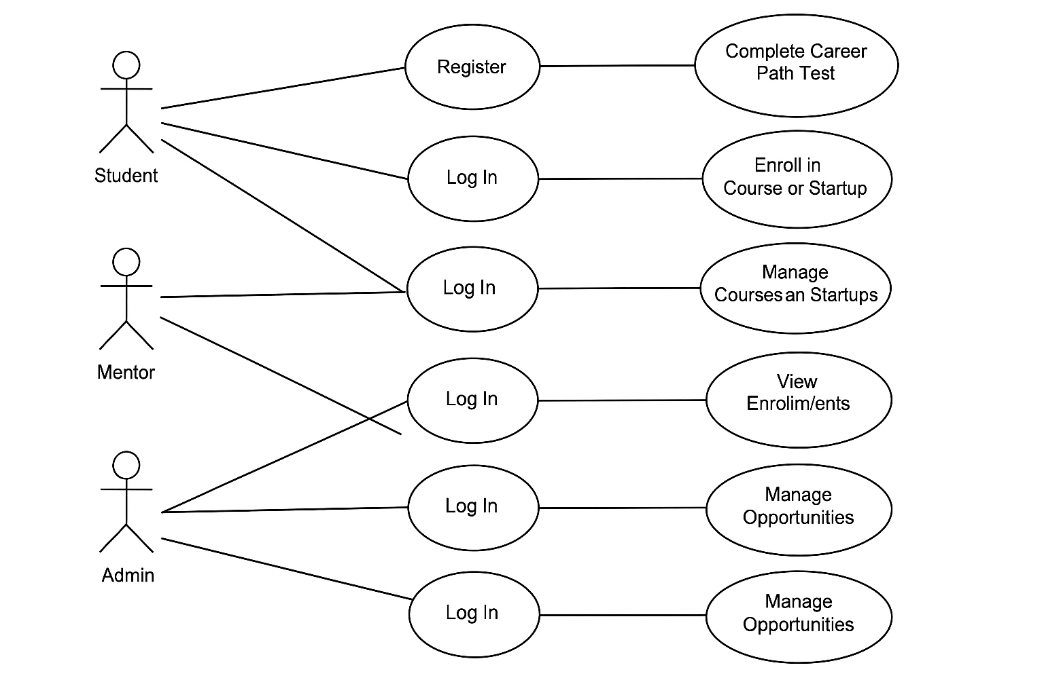

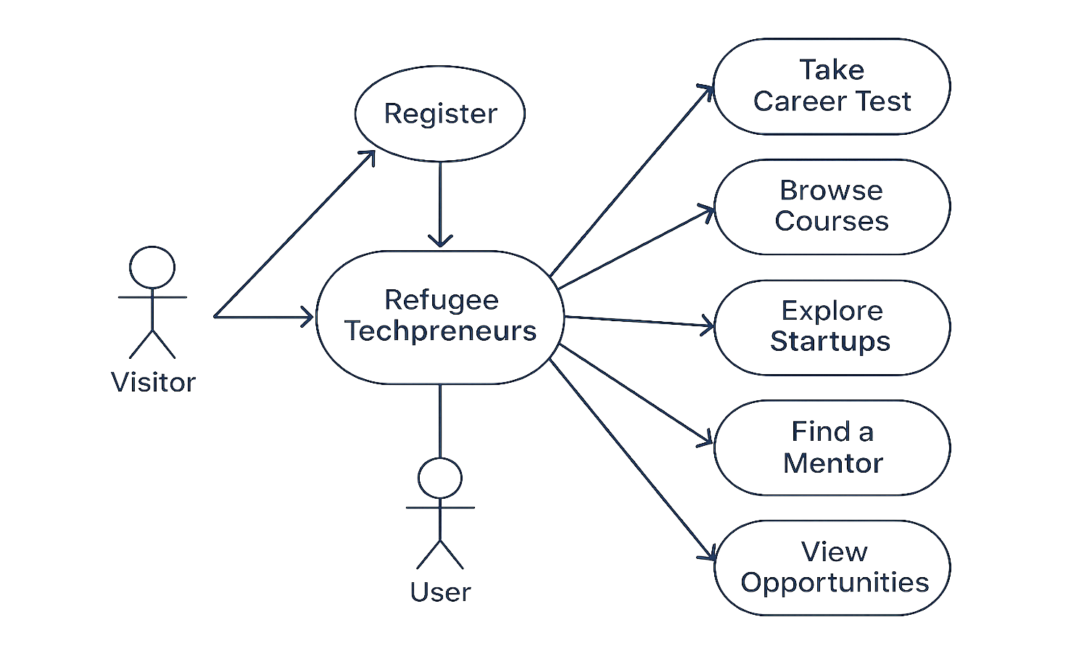

**3.6 Development Tools**

* **Frontend Development:** React.js/HTML, CSS, JavaScript, enhanced with Tailwind CSS for responsive UI design.
* **Backend Development:** Node.js and Express.js for handling API logic and data routing.
* **Database:** MongoDB.
* **AI Integration:** Python (Flask API) to deliver personalized career insights based on user input.
* **Version Control:** Git and GitHub for collaborative coding and codebase management.

**References (APA Format)**

Aikins, K., & White, L. (2019). *Artificial intelligence for humanitarian action: Opportunities and challenges*. Humanitarian Technology Initiative.

Betts, A., Bloom, L., Kaplan, J. D., & Omata, N. (2017). *Refugee economies: Forced displacement and development*. Oxford University Press.

Coursera. (n.d.). *Online courses from top universities*.<https://www.coursera.org/>

EdX. (n.d.). *Access 2500+ online courses from 140 institutions*.<https://www.edx.org/>

IBM. (n.d.). *IBM Watson Career Coach*.<https://www.ibm.com/watson-career-coach>

Kolibri. (n.d.). *Learning Equality: Kolibri*.<https://learningequality.org/kolibri/>

NaTakallam. (n.d.). *Connecting displaced persons with income opportunities through language*.<https://natakallam.com/>

Pymetrics. (n.d.). *Career matching powered by neuroscience and AI*.<https://www.pymetrics.com/>

RACHEL. (n.d.). *Remote Area Community Hotspot for Education and Learning*. World Possible.<https://worldpossible.org/rachel/>

RefugeeCode.org. (n.d.). *Empowering displaced youth with coding skills*.<https://www.refugeecode.org/>

UNHCR & ILO. (2020). *Promoting livelihoods and decent work for refugees and host communities: A mapping of global practices*. United Nations High Commissioner for Refugees and International Labour Organization.<https://www.unhcr.org/>